Experiment 12
Aim:
To implement a Tic Tac Toe game in Python where two players take turns to place X and O and the program determines the winner or draw.
Algorithm:
- Start
- Create a 3×3 board with all positions empty.
- Set the first player as X.
- Display the board.
- Ask the current player to enter a position from 1 to 9.
- Check whether the selected position is empty.
- If occupied, ask the player to choose another position.
- Place the player's symbol (X or O) in the selected position.
- Check all possible winning combinations.
- If the current player has three symbols in a row, column, or diagonal:
- Display the board.
- Declare the player as the winner.
- Stop.
- If all 9 positions are filled and there is no winner, declare a draw.
- Otherwise, change the player from X to O or O to X.
- Repeat steps 4–11 until the game ends.
- Stop.
Code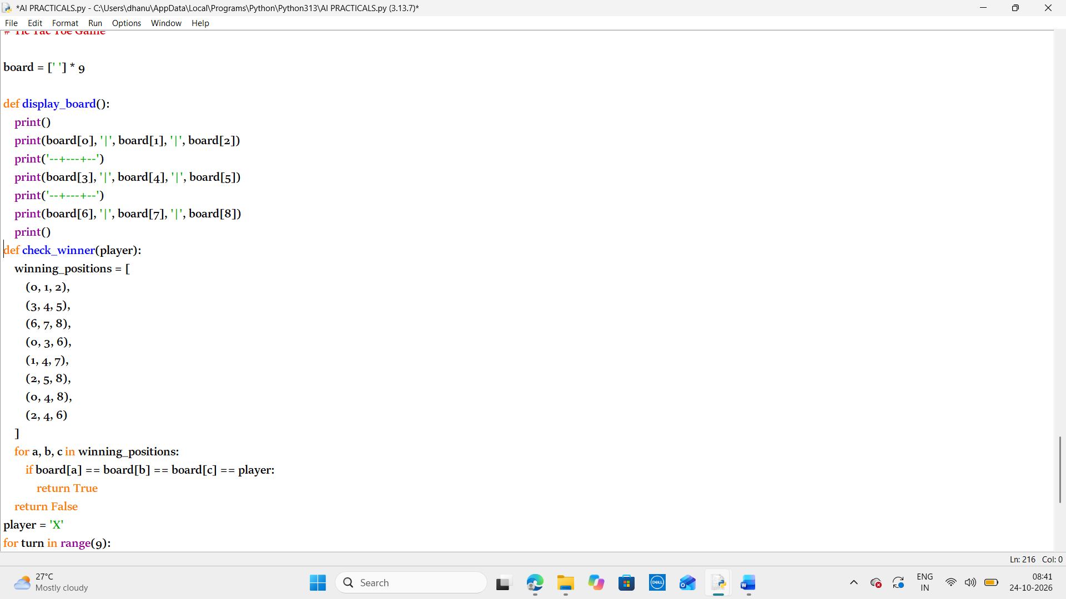de:

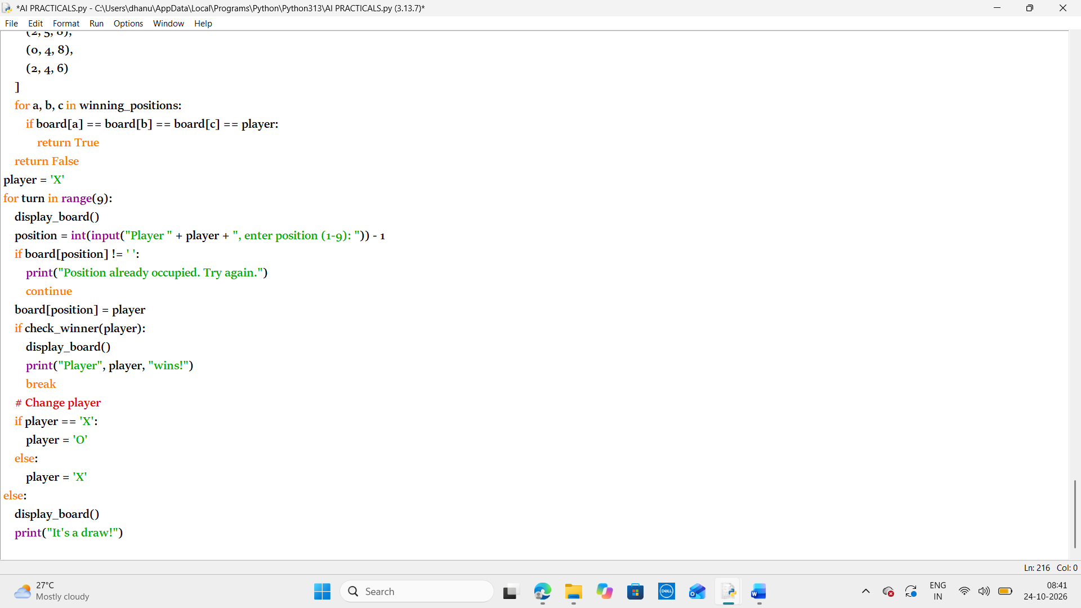
Output:
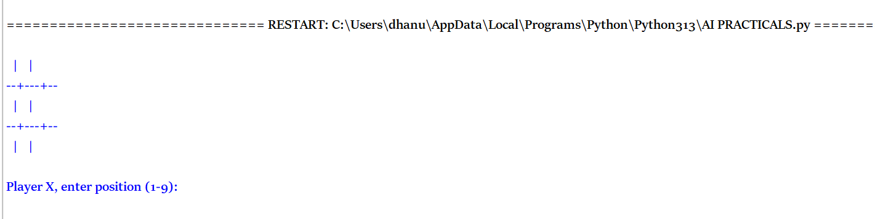
Result:
Thus the python program to implement a Tic Tac Toe game in Python where two players take turns to place X and O and the program determines the winner or draw has been executed successfully

